Innovations in
Housekeeping

The Impact of Mobile Applications on Improving Housekeeping Scores, Guest Satisfaction and your Hotel’s Bottom Line.

12_2_13_rev7

Executive Summary
Room cleanliness has been demonstrated to be a leading indicator of guest satisfaction survey scores. However, existing methods for room inspection are tedious, labor-intensive and do not provide management the tools required to effectively manage housekeeping.
Innovative new mobile application solutions are now helping hotels to streamline the room inspection and data collection process, while providing key decision makers real-time business intelligence with up-to-the-minute performance summaries and reports.
The impact is significant on how hotels operate, how staff members perform daily tasks, and how housekeeping staff are managed.
Case Study
For hotel guests, the room experience is an important part of their stay. Hotels therefore spend significant resources to ensure that their guest rooms are clean, comfortable, and have all the necessary amenities to match their guest’s expectations.
One of the major challenges for hotel management is to maintain a high level of quality all year round, while containing costs. Any product or process that makes the housekeeping staff more efficient has a direct impact on the hotel’s bottom line.
Housekeeping inspections is an ongoing job at every hotel, every day. To achieve excellence in housekeeping, it is critical to conduct high-quality, consistent, daily room inspections, and to ensure that every room and every room attendant is regularly inspected for compliance to standards.
vInspect, an innovative mobile application from VSi, runs on a variety of mobile devices, replacing paper form-based inspection processes with electronic housekeeping; while enabling hotels to conduct high-quality, consistent, daily room inspections in a very cost effective and efficient manner.
Housekeeping Today
For a vast majority of hotels today, room inspections are a manual process. A pre-designed paper form is completed and hopefully becomes part of a property-wide report. This report is sometimes completed at week’s end, month’s end or maybe never. Data is often reviewed in historical context, rather than as a real time management tool. Corrective measures are more meaningful when addressed now, rather than later.
This “paper chase” process is tedious, labor intensive and does not provide management the tools to effectively manage housekeeping. There are no benchmark standards for the number of inspections completed nor is there an effective mechanism to provide real time feedback to room attendants who might require corrective actions.
With manual inspections, the format and availability of data across multiple properties is inconsistent, making it difficult for management to determine relative performance of one property versus another. The manual nature of these inspections also leads to issues such as the same rooms getting inspected over and over again and other rooms never getting inspected, or repeated inspections of the same housekeepers while others are rarely scored.
Mobile Technology in Action
Using VSi’s mobile technology, “mAPPs” eliminates the need for paper reporting and streamlines the availability of information and decision making.
This innovative mobile applications suite allows hotel staff to conduct ongoing, routine operations faster and easier, in real time - without paper reports - so properties can operate more productively and more profitably.
vInspect is one example of a VSi mAPPs solution in action.
vInspect Mobile App
The process of conversion from a paper-based system to electronic forms is straightforward and simple. The room inspection paper form is converted into a vInspect app that can be displayed on a mobile device (iPhone, iTouch, iPAD, etc.) and all proprietary information about the room attendants, room inspector, and hotel room information is added to the vInspect application.
Room inspectors walk into a room, and enter the inspection information on their mobile device. Once completed, this information is uploaded to the cloud using the existing WiFi network or cellular technology. This information, in real time, becomes available to the management via VSi’s web-based reporting portal.
The scoring can be a mirror image of current paper reporting or can be customized to reflect changing trends at the hotel. Notes, pictures and signatures can be added electronically to the mAPPs report prior to completion of the inspection.
To start a room inspection, the inspector selects the Room Attendant from a list. Points are deducted from the inspection for any items that are missed. Scoring is based on different weights assigned to different tasks. Inspector may click the Notes button at any time to add notes. Inspector’s signature can be captured at the end, if required. Summary scores are shown at the end of each section and the overall inspection. The App has a capability to store up to four photos that can be can be taken with each inspection to document how the job was done. When an inspection is complete, the Done button is selected to move on to the next inspection.
Once completed, the inspection data then waits in a queue to sync with the cloud database. Prior to syncing with the cloud database, saved inspections can be revised or deleted by selecting the Edit button.
When data is synced by an Inspector from a mobile device, the entire vInspect database is refreshed and all information is available on the web portal.
The vInspect web portal is accessible to any member of the management team with appropriate authorization. Only a team member with administrative privileges has authority to make changes to the information. All others can only view information. The reports can be accessed from any internet browser with an appropriate access code.
A wide selection of reports is available: from inspection summary to a detailed history of each inspection. Reports are built with flexibility and customization in mind. All reports can be refreshed with the latest live data and exported into Excel. Data can be queried with filters for Date Range, Evaluator, Attendant, Score sliders and much more. Drop-down filters feature check boxes allowing viewers to choose whatever suits their needs. Simple analysis of data can quickly reveal which rooms are inspected more frequently than the others and also allow creating a balance in job assignments for each housekeeper.
The Management Dashboard
You can’t improve what you can’t measure. One key advantage of Electronic Housekeeping is that it allows hotels to create custom management dashboards. These dashboards can summarize key issues in housekeeping for senior management’s review, allowing them to make fast, informed decisions and take appropriate actions. It quickly allows them to determine if the problems are due to personnel, process, or training. It also enables management to compare the performance of a property with other locations and work with a much larger sample size.
The dashboard data also acts as a leading indicator and allows management to take corrective actions well in advance. Management can conduct daily morning meetings with housekeeping staff with the most recent performance data and back-up documentation to commend best performers or take corrective actions, including training for subpar performance.
Some of the most common dash board parameters include the following:
- List of Top performers
- List of Bottom performers
- List of most common problems reported

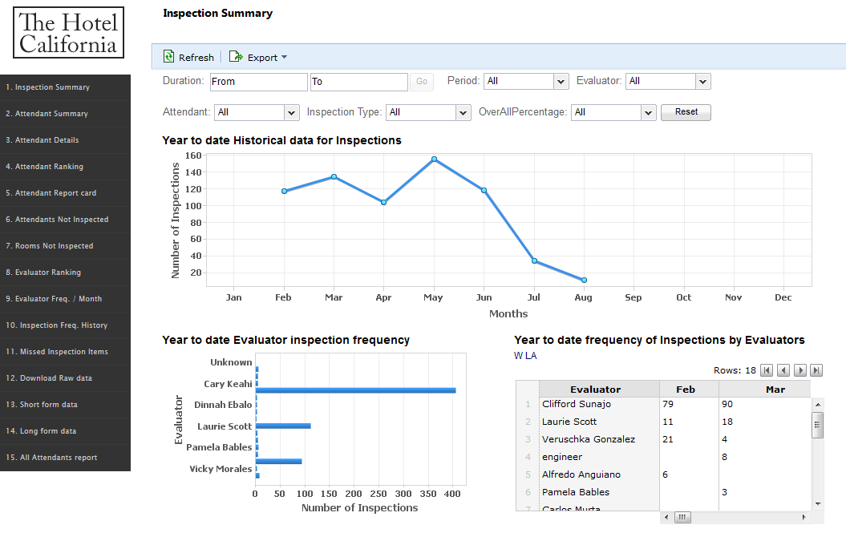
Management Dashboard

Benefits of using Electronic Housekeeping:
- Improves quality and productivity versus manual inspection times.
- Allows housekeeping management to focus on recurring problem areas in real time.

- Provides a reporting platform and dashboard, allowing for fast management decision making.
- Has been demonstrated to improve coaching, as sessions can be targeted to the specific area requiring improvements and are supported by pictures of conditions found.

- Reduces staff turnover by improved coaching and training.

- In situations where coaching is not effective, provides HR with documented correction record to support termination decision.

- Improves employee morale as “top scoring” room attendants are celebrated in real time.
- Improves compliance to standards and consistency of record keeping.
An Example
Recently, a major Chicago skyline property implemented the vInspect solution, and was able to determine that going paperless improved productivity, quality and guest satisfaction feedback measurably. Because inspections were easier, they were conducted more often – for example, increasing from an average of two per day per housekeeping employee to eight per day.
While more data was generated, management was able to provide feedback more quickly to staff about their performance – and staff reacted more quickly to correct problems. The result: more satisfied employees, who no longer dread inspections but rather found themselves wanting to do more inspections.
With traditional inspections, a particular problem could go on for days or even weeks before it would be properly identified and corrected. With mAPPs, problems could be caught and corrected quickly – while they were still occurring, before they got out of control, and before they could affect guest satisfaction
Conclusion
As more paper based reports and processes are converted into mobile applications and new tools are developed as part of this mobility trend, the hospitality industry will see a new horizon of management capabilities.
This paradigm shift will allow hotels to establish property-level goals for inspection and other activities. It will allow each department to set targets for each person involved and monitor progress. It will ensure that each person performs consistently against quality objectives. The real time feedback that is fully documented can be used for both – positive reinforcement as well as constructive feedback. This will also help hotels design and manage effective staff training programs.
But this is only the beginning of this paperless revolution. It won’t be long before a hotel manager, or the owner of a group of hotels, will have the ability to manage as easily from a distance as they do “up close and personal”, providing the ability to be in multiple places at the same time and able to manage performance, productivity and guest satisfaction.
In summary, mobile apps will allow hotels to run highly efficient back-end operation, reduce labor cost, improve the bottom line, while enhancing their guest’s experience with more consistent quality.

Founded in 2001, in the heart of California’s Silicon Valley, Vertical Systems Inc. (VSi) develops state-of-the-art mobile applications and smart lobby solutions for the lodging industry. These applications serve hoteliers with meaningful efficiency-oriented tools and guest-facing products that increase staff productivity and enhance the guest experience. With over 10 years of experience, and more than 1000 installations worldwide, VSi’s technology solutions provide hoteliers with the competitive edge that allows them to concentrate on what they do best – hospitality.

Nabeel Saeed is a Product Marketing Manager at Vertical Systems, Inc., a Silicon Valley-based technology company that provides sophisticated solutions for the hospitality industry through a wide range of smart lobby solutions, mobile applications, and in-room products.

With a background in statistical analysis of markets, product and graphic design, marketing, and art direction, Nabeel has creatively blended his diverse interests to drive innovative user experiences in emerging markets. He helped design, develop, market, and sell workflow technologies that are revolutionizing the hospitality and healthcare industry.

Nabeel earned an undergraduate degree in Economics, with a focus on econometrics and stochastic modeling, at the University of California – San Diego. He also conducted market research at San Diego’s World Trade center and at a Bay Area think-tank.

